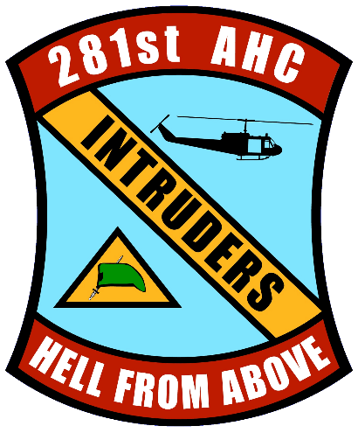

Dear Candidate:

Enclosed please find the requisite documents to assist you in applying for a scholarship grant from the 281st Assault Helicopter Company Memorial Scholarship Program. In order for you to be considered for a scholarship from our program, the following documents must be provided and postmarked no later than June 15 of this year.
- Completed application
- Acceptance letter from the college that you will attend
- High School/College Transcripts
- SAT and/or ACT scores (if available)
- Three (3) Teachers Evaluation Forms: with one from a teacher of the subject in which you plan to major
- A Letter of Recommendation from each teacher above
- A High School Counselor’s Evaluation Form
- A Letter of Recommendation from an individual who has known you for at least four (4) years
- Completed Checklist showing you have assembled and included all required documents

Please have your High School Counselor attach your high school transcripts and test scores to his/her evaluation form. Please assemble your complete application package and submit one packet to us by U.S. mail or package delivery service (UPS/FedEx) to the address below:

Ms. Joan Baker
186 Zostera Drive
Little River, SC 29566
scholarship281secy@icloud.com
336-314-2540

